NAME: PRATIBA.S DATE:23.09.25 ROLL NO.:241901080

# EXERCISE 8

**BUILDING ANONYMOUS FTP SCANNER USING FTPLIB MODULE**

**INTRO:**

FTP is a legacy protocol used for transferring files between hosts. Some servers allow anonymous login so the public can upload/ download files according to server policy

**AIM:**

1. Demonstrate house an FTP client can test for anonymous access on a target list of hosts
2. Record and classify responses
3. Evaluate potential security implications and produce a reproducible report of findings
4. Emphasize ethical / legal cons

**ALGORITHM:**

1. Gather authorization and targets
2. Set conservative test parameters
3. Prepare logging
4. DNS resolution
5. Attempt anonymous login
6. Post processing
7. Clean up and reporting

**CODE:**

import ftplib  
def anonymousLogin(hostname):  
    try:  
        ftp = ftplib.FTP(hostname)  
        response = ftp.login('anonymous', 'anonymous')  
        print(response)  
        if "230 Anonymous access granted" in response:  
            print('\n[*] ' + str(hostname) +' FTP Anonymous Login Succeeded.')  
            print(ftp.getwelcome())  
            ftp.dir()  
    except Exception as e:  
        print(str(e))  
        print('\n[-] ' + str(hostname) +' FTP Anonymous Login Failed.')  
hostname = 'ftp.be.debian.org'  
anonymousLogin(hostname)

**OUTPUT:**

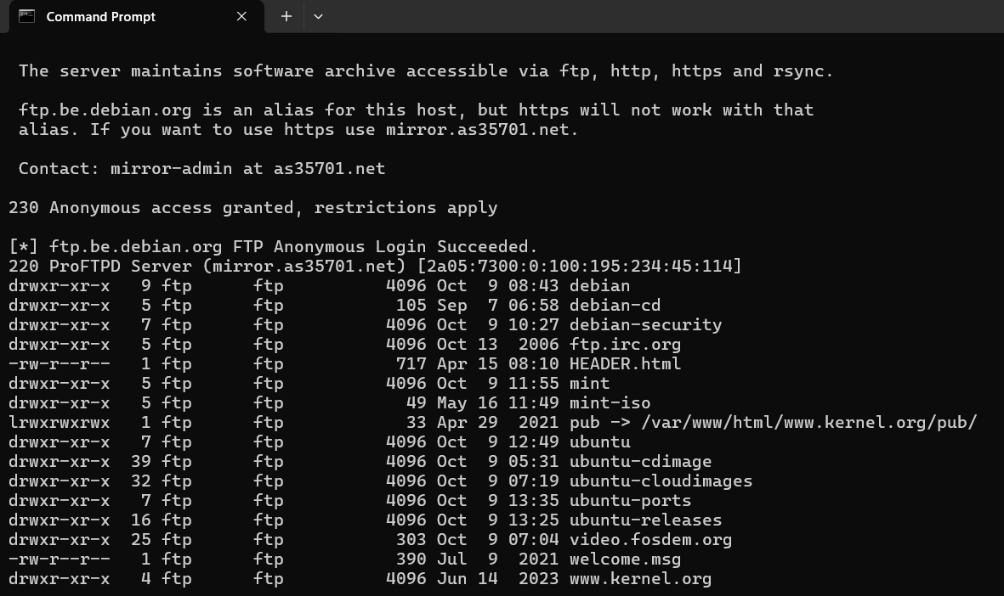

**RESULT:**

Thus, the anonymous FTP scanner has been built using Ftplib module successfully.